

**INDIVIDUAL ASSIGNMENT**

**TECHNOLOGY PARK MALAYSIA**

**BM050-3-3-IMNPD**

**Innovation Management and New Product Development**

**INTAKE CODE – NP3F2104IT**

**HAND OUT DATE : 29 December 2021**

**HAND IN DATE : 25 March 2022**

**WEIGHTAGE : 60%**

**Topic: Google pixle 6 pro**

**Submitted by: Submitted to:**

**Bishwo Nath Shrestha Dr. Sunit Adhikari**

**NP000304 Lecturer**

**___________________________________________________________________________**

**INSTRUCTIONS TO CANDIDATES:**

1. Submit your assignment at the administrative counter.
2. Students are advised to underpin their answers with the use of references (Cited using the Harvard Name System of referencing).
3. Late submissions will be awarded zero (0) unless extenuating Circumstances (EC) is upheld.
4. Cases of plagiarism will be penalized.
5. The assignment should be bound in an appropriate style (comb bound or stapled)
6. Where the assignment should be submitted in both hard copy and softcopy, the softcopy of the written assignment and source code (where appropriate) should be on a CD in an envelope/ CD cover and attached to the hardcopy.
7. You must obtain 50% overall to pass this module.

**ACKNOWLEDGEMENT**

Primarily, I would like to express our gratefulness and thankfulness to the Module lecturer of Innovation Management and New Product Development (BM050-3-3-IMNPD), Dr. Sunit Adhikari sir for his guidance throughout the module including this assignment and for providing us with instant feedbacks through any means possible.

I would like to show a sense of respect to the coordinator of BSc.IT, Mr. Jyotir Moy Chatterjee for his supervision. I am equally grateful to the Dean of Lord Buddha Education Foundation (LBEF), Dr. Sandeep Kautish for his instructions. I would also like to acknowledge all the teaching and non-teaching staffs of LBEF, classmates, friends, seniors and entire LBEF management team for providing capable help, even in the pandemic situation.

I am thankful toward our entire BSc. (Hons.) IT faculty members, LBEF Campus and Asia Pacific University (APU) for developing and implementing such a practical module and giving us an opportunity to asses this real-case project.

**Bishwo Nath Sapkota**

**NP000304**

**6th Semester (Level – 3)**

**BSc. (Hons.) in Information Technology (IT)**

**Lord Buddha Education Foundation (LBEF)**

**Executive Summary**

Google, originally Google Inc. (1998–2017), is an Alphabet Inc.-owned American search engine firm founded in 1998 by Sergey Brin and Larry Page. Google is responsible for around 70% of all global online search inquiries, putting it at the center of the majority of Internet users' experiences. Mountain View, California is the company's headquarters. A smartphone is a portable device that combines the features of a phone and a computer into one device. They differ from feature phones in that they have more powerful hardware and mobile operating systems, which allow for more software, internet (including web browsing over mobile broadband), and multimedia functionality (including music, video, cameras, and gaming), in addition to standard phone functions like voice calls and text messaging. Smartphones typically contain a number of MOS integrated circuit (IC) chips, as well as a variety of sensors that can be used by pre-installed and third-party software (such as a magnetometer, proximity sensors, barometer, gyroscope, accelerometer, and more), and support wireless communications protocols (such as Bluetooth, Wi-Fi, or satellite navigation). Google showcased the Pixel 6 and Pixel 6 Pro on August 2, 2021, confirming the phones' updated looks and the addition of its proprietary Tensor system on a chip (SoC). Previous Pixel smartphones utilized Qualcomm chips, although Google starting development of its own chips (codenamed Whitechapel) in 2016. Both Google's TensorFlow and Tensor Processing Unit (TPU) technologies are referenced in the chip's name. Despite the fact that the chip is touted as being developed by Google, thorough study reveals that it has many characteristics with Samsung's Exynos series. By October 2021, a replacement to the processor was said to be in the works, perhaps for the Pixel 7.

Table of Contents

1. Introduction 1

2. “NEWNESS” of the product 2

2.1. Brand new design: 3

2.2. Display: 4

2.3. Performance: 5

2.4. Cameras 6

2.5. Battery 6

3. The new product development processes 7

3.1 Understand customers’ needs: 7

3.3.1. Collecting feedback from the customer. 7

**a.** **Feedback from customer:** 7

**b.** **Surveys:** 7

**c.** **Interviews:** 7

**d.** **Social media:** 7

**3.1.2.** **Keep a Close Eye on Your Competitors** 8

**3.1.3.** **Create a “Customer Needs Statement”** 8

3.2 Idea Generation 8

3.3 Idea selections: 8

3.4 concept development and concept testing: 8

3.5 Product development and product testing: 10

3.6 Market testing and commercialisation 10

4. Weakness and strengths of product’s development~~s~~ process and ethical implications. 11

4.1 Weakness of product’s developments: 11

4.1.1 Unrealistic expectations. 11

4.1.2 Products can fail unexpectedly. 11

4.1.3 Product testing bad requirement can result in a failure of the project idea. 11

4.2 Strengths of product’s developments: 11

5. Conclusion 13

6. Reference 14

# Introduction

As we all know that smartphone have become very popular as well a daily necessity for people life. Smartphone can be defined as a device that work with interaction with the internet and you can get to use full functions of a phone with the internet. In addition to the advantages of the Internet, smartphones provide qualitatively new services. (Cha S-S, January 2018)



Figure 1: Google company

Google, formerly Google Inc. (1998–2017), is an American search engine company founded in 1998 by Sergey Brin and Larry Page and owned by Alphabet Inc. Google is responsible for more about 70% of all worldwide online search queries, placing it at the heart of most Internet users' experiences. The company's headquarters are in Mountain View, California. (Hosch, 2020) The famous company google finally entered into mobile industry

was made possible by its 2005 purchase of Android Inc., which had yet to deliver any devices at the time.

With the introduction of the Nexus One smartphone in 2010, Google become strong enough to go ahead with apple iPhone. Nexus which is the phone made by google was dubbed the because it ran the old version of Android, it had a large, vibrant display screen, an attractive design, Though, when compared to other phones in its class, its absence of built-in assistance for multi-touch an Apple-invented navigation function that was very helpful, users got more freedom in cooperating with touch screen was considered as a disadvantage. Despite its apparent disadvantages when compared to Apple.

Google was forced to fight competitors in the courts as well as in the marketplace over Android. Oracle Corporation, for example, sued Google in 2010 for $6.1 billion in damages, alleging that Android had infringed on multiple copyrights related to Oracle's programming language. (Google finally won the lawsuit after two years in court.) Instead of openly challenging Google, Apple Inc. has filed patent infringement lawsuits against HTC, Motorola Mobility, and Samsung, among others.

# “NEWNESS” of the product

Newness can be defined in product as evolution to previous and successor of old version of the product. google has launch a brand new smartphone known as pixel 6 pro along with pixel. According to the google official website the new pixel 6 pro cost around eight hundred nine pounds, with the release of this new smartphone it has lived up to user expectation or it may have given its user more than their expectation. As we all know khat the vital feature that the people like to have in any new phone, people like to have good camara, display, battery and many more in budget price. To meet the user expectations google has lunch the brand-new phone with a redesigned design, better camera, faster operating system, and new machine learning processors.

Unlike the previous version of the pixel smartphone, which were mid-range phone however, these new models are designed to compete directly with Apple and Samsung.

As we might be wondering what the different between the new product between the normal version and the pro version, its quite simple the only different between them are the variances in camera, screen size, and pricing however, the phone core remains the same as the pro version of the model.so the if you are wondering to choose between them , I would like to suggest if your budget is tight go from normal version if not than you can go for the pro version.

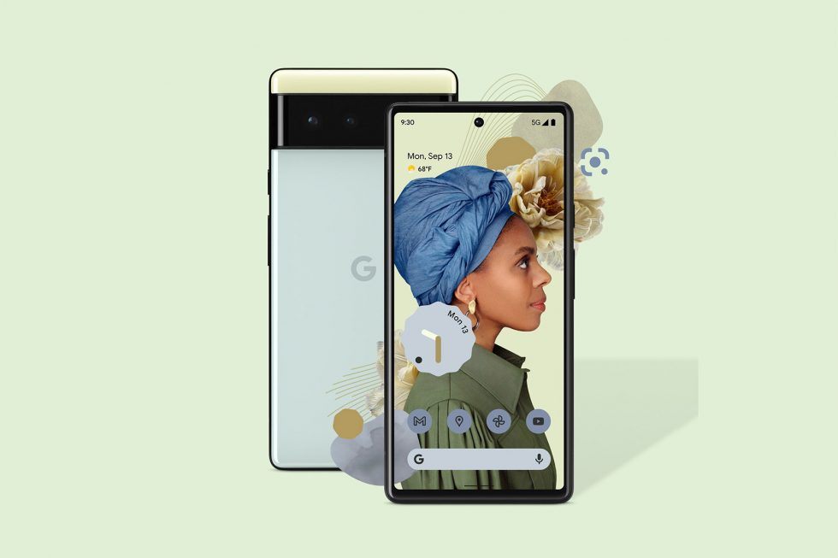

If you compare the new pixel to its previous the new 6 pros are undoubtedly the most pleasing Pixel phones to this date,

with the improved designs and more evolution feature then the previous.

google has quite the expectation from the new pixel 6 pro that it with the good combination of overall area of hardware with the software, google hopes to change the world of smartphone and with the better luck to become the best mobile phone to release in the year 2022. So the other competitor should keep watch of their customer if not then the google will take the market of smartphone.

Here is the newness of the pixel 6 pro:

### Brand new design:

As all that have released before have very classic look like the old design but do not worry the new model has a new design. If you look at the all the design of the pixel than you probably know that they all don’t have that of a great design but with the new pixel you will be shocked to see the improvement of the design. It’s like that the new pixel pro has got the best glow up ever in the design part. They have change horizontal camera bar (rectangle shape) running across the top of the device's back, look need and clean as well as it stand out in the market because the usually the camera comes in square at top-left side of the phone. Most people like put case in the phone so if you don’t like to leave finger stamp at back then all you have to do is buy the case to cover it.

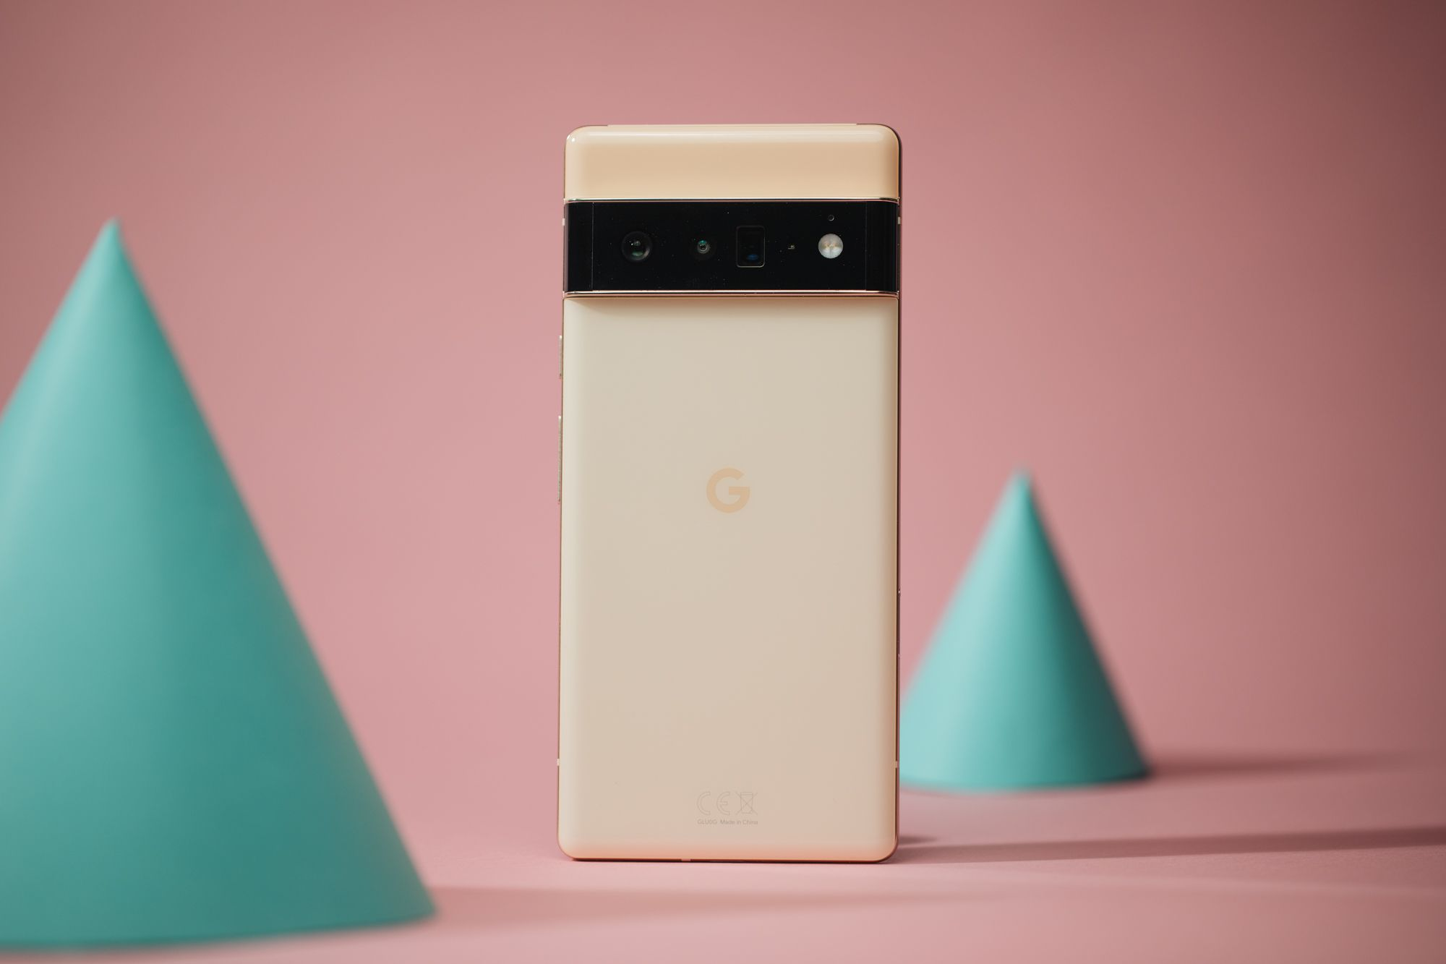

Both phones feature a glossy glass back that feels decent in the hand but isn't nearly as gratifying as the Pixel 5's matte resin, the Pixel 4's smoothness, or Samsung's somewhat slimmer note 20 ultra. Hopefully, future Pixels will continue this trend, as no phone has yet exceeded the sensation of the Pixel 4.

The design for the fingerprint scanner in the previous pixel was at the rear as for the facial id on the front but in the new pixel 6 pro the company has chosen to put the fingerprint scanner beneath the screen and claim that this method is more secured and hole-punch for the front camera. This will parentally disable the feature like gazing at the screen to verify notification information however, compare to the security that make user feel safe, it’s a fair trade off.

### Display:

With the new design comes the new display to match the premium design of the phone, it has boast bright, punchy screens that will surely please everyone those see its display. Since the display is one of the mobile greatness weaknesses, to make this weakness the strength it has built the display with gorilla victus which will add durability for the phone in case it dropped from high height. The new gorilla victus gives the most durability up to date which is in pair to what Samsung has to offer.

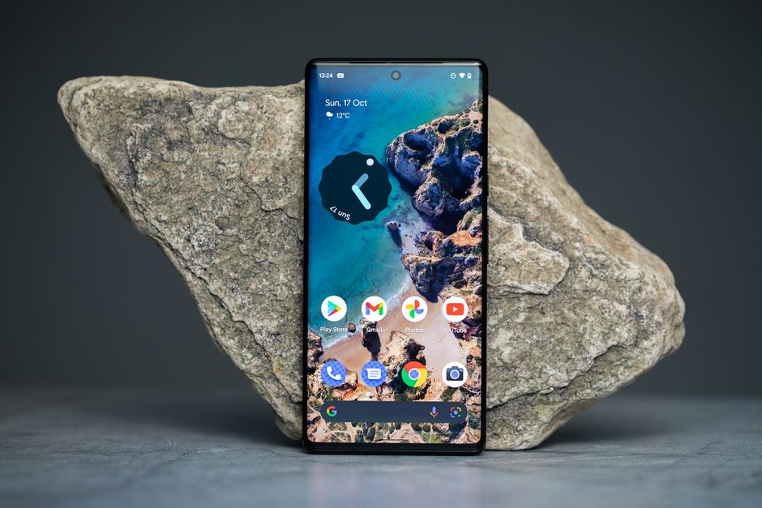

Another good thing about the display of pixel 6 pro, that it has 6.7 inch with 1440p screen with thinner bezels. this is by far the tallest in the history of pixel family with the very clear quality picture. It also comes with refresh rate of 10-120Hz it ensures that while using the phone that user will feel smooth as butter. refresh rate represents the smoothness and responsiveness of the screen which will make game faster and overall navigation of the phone smooth. it also allow to save power while display is not being used.

The body is made up of metal around side part of the phone and edge of the four-corner side is of square, this will feel premium while looking at the display.

### Performance:

As the matter of the performance, the brand-new chip which is built by google, which is called google tensor it is said to be compete with Qualcomm’s snapdragon 888 which is the latest chip used in many android flagship phones. The Pixel 6 has 8GB of RAM and 128 or 256GB of storage, while the Pixel 6 Pro has 12GB of RAM and a base of 128GB of storage that can be expanded to 512GB.

The application will open without any slight delay and will response immediately as it is expected from the high flagship phone from 2021. However, app may crash abruptly rarely, which cannot be good because this happens so seldom, user won’t be able to notice it. We're a little surprised by Google's boasts of customization at this level of development; we don't use widgets very frequently because we prefer to utilize the real estate on our phone's screen for apps, but even if we did, having them be a slightly different color is hardly the be-all and end-all.

May be the update will fix the issued and then user won’t be able to feel the difference and will enjoy the smoothness of the mobile. However, after you have the Pixel in your hands, it performs exactly like any other phone. The Android 12 UI is quick to explore, games like Asphalt 9: Legends and Call of Duty run smoothly, and picture editing and video streaming work just as well as they do on any other high-end phone right now. (Lanxon, 2022)

### Cameras

The thick bar on the rear conceals three cameras; 12mp ultrawide, a 48mp telephoto it also has 4x optical zoom, as well as a primary camera with a superior 1/1.3-inch sensor that, according to Google, collects 2.5x lighter than the Pixel 5. Pixel phones have always had amazing cameras, and this latest generation is no exception. (Lanxon, 2022)

Well, I was surprised there when I looked at the camera of the ne mobile since it always has the good camera in older phone but this new model has something better to offer. The pictures taken by the primary lens of the camera are breathtaking. They're vivid, full of texture, and have a superb contrast balance, with brilliant sky maintained within control and dark places clearly apparent.as to compare the camera with another great brand phone Samsung Note 20 Ultra, both have the best camera available in android phone.

When photographing a white structure against a dark grey cloud, the Pixel 6 pro has a little better feeling of contrast and handles colors more naturally than its competition. The Pixel 6 pro has a somewhat better understanding of contrast and handles colors more naturally than its competitors when capturing a white edifice against a reddish-brown sky.

### Battery

Battery is one of the essential part of the phone if the product have low battery capacity But their software is heavy then the phone battery will be down at fast rate however, if the phone has big battery and power efficient phone then the product will be successful.

Both the Pixel 6 pro (5004mAh) have excellent battery life, which is a significant gain over the Pixel 4 XL. Even after a full day of heavy use — shooting photographs, playing games, and watching films – the phones lasted until the next morning without needing to be charged.

One of the disappointers is that Even though Google's suggested 30W power adapter (which you'll have to buy separately), there's no chance for quicker charging speeds because the Pixel 6 can only handle a maximum of 23W of electricity. It takes more than 2 hours to fully charge the battery with this method.

# The new product development processes

## Understand customers’ needs:

Product are made for customer need and if the company does not listen to what customer has to san than the company will not last longer and will go bankrupt. In order to understand customer, need you need to identify the types of customers and then their needs. Google also understand its customer needs so that it product is always hi in the market.

Here are the following ways in which company can know the customer needs:

### Collecting feedback from the customer.

1. **Feedback from customer:**

It is one of the best ways to understand the user, which is to ask for customer feedback about the product. A simple and direct method to understand user. Google company use this technique to know what is need in their product.

1. **Surveys:**

Another great ways to gather information to understand the user, there are many introvert people that don’t like to give feedback or they don’t want company to know that the user is commenting on the product, for those type of people this will be very helpful to fill then say. Since the user is unknown in the survey many people tend to fill the survey. Google use many survey to get information about their product feedback, an online form is always helpful now a days then written survey.

1. **Interviews:**

Another great way but not many people preferer this because no one want to go to interview in their daily busy life, however this can be also used to understand user need.

1. **Social media:**

This may be the best ways considering that many people use internet now a days almost all people have access to social media. Company can post about review of their product in social media and there will be many people to comment the post. Google is always active is social platform.

* + 1. **Keep a Close Eye on Your Competitors**

Company should always keep eye to eye with the customer because the they always want to influence the. Customer and your company should always be aware about it.

* + 1. **Create a “Customer Needs Statement”**

Customer statement is needed for customer services to know the customer needs

In this, the note is all about who are they, what is that they buy, what is expected, price, does it make user feel good? Is kept so that their will be proper analysis of what the user wants.

These are the few ways in which company can use to collect the information about the product and understand the customer needs.

## Idea Generation

In this phase, it’s all about generating creative ideas. This phase highlight about all the customer problem and then analysing the problem that are listed after identifying the possible solution of the problem and at last to sum up with one final problem statement with the solution.

## Idea selections:

In the sector. the idea about the product should be different then other or it should be unique is said in this phase. If the product match the other existing then new name for the product is required. It's also about figuring out which idea has the highest probability of success.

## concept development and concept testing:

In this phase it is all about building the concept for the product and testing it if it actually make sense or not. All the user requirement is sum up and test all the user requirement to check whether it is possible to make the product or not.

## Product development and product testing:

**Product development:**

In this phase, focus in developing the product and adding feature to existing system.

Google pixel can add new feature like more advance chip or it can update the camera quality of the pixel 6 pro. All the related work that to do with adding or updating the feature takes place with make sure that the produced is ready to deploy.

**Product testing:**

Testing of the product is done in this phase of the development process, all the bug is identify and are listed to be solved and if only it pass the test it will go to next steps. In this step. In google pixel the company will test all the feature to make sure that ti is working all fine and all the user requirement is filled.

## Market testing and commercialisation

**Market testing**

The product testing will check all the product is working or not however, marketing testing will whether the product is ready for the market or not. This stage of the Planning phase tries to reduce the degree of uncertainty in the piece of software that has been generated so far. It assists in determining the feasibility of a new business or marketing plan. It contains two types of testing; beta and alpha testing.

**Commercialization**

Users are probably acquainted with for this stage of the NPD process. The company has been committed all they need to bring the finished product to the market during commercialization, including sales and service strategy. The team begins to put the company's production and customer support into action.

# Weakness and strengths of product’s development~~s~~ process and ethical implications.

## Weakness of product’s developments:

## Unrealistic expectations.

If the user request unrealistic then it is likely to be fail abruptly, no matter how many time it is done.so the usre should provide realistic expection to get the product he/she wanted. The poor design is one of the minor issues of pixel 1.

### Products can fail unexpectedly.

Sometimes product fails un expectantly cause of bug as other software/hardware component. It happened with xiomi mobile, some user reported to have explode the device.

### Product testing bad requirement can result in a failure of the project idea.

Sometimes if the product testing is failed all the project can be failed. this is due to lack of planning, unrealistic feature and many more.

* + 1. **External sources can change procedures your product development.**

The final output of the product can be stopped if there is no enough resources. So while making the product company should take care of internal as well as external factor that affect the products.

## Strengths of product’s developments:

1. It creates a culture of innovation.

After the start of one successful product with the idea, it will aid the next product to be more successful and so on. the income gain by the idea will leverage the other ideas. each process built to make one and the business can acquire market share.

1. It helps to drive a higher proposition.

Once the product is hit in the market, and the company next product will fulfil the user requirement, which will then generate greater income and increase in quality will encore customer to buy the product.

1. Consumers will be egger to try latest products.

After wating for the pre-order product when the finally time to received the customer are hype about trying the product. Because your emphasis on innovation becomes their innovation, they will be willing to try new goods people like to get their hands on the new product as fast as they can and they will support the company.

1. Network.

When their product is good , customer will try to make network with the entrepreneurs because they can get the latest news about upcoming product and this will build the network of owner and customer.

# Conclusion

In conclusion, the new Pixel 6 pro has many to offer to its user and it can bring good value to table so the customer wants to buy the new mobile. In my opinion, the new pixel 6 pro is a eccentric phone, particularly at the shockingly low-cost price, and I would gladly recommend it to everyone since it is kind a like getting flagships phone with the mid-range budget price. Since the previous was good phone but over the course of evolution the new series is the best of all the previous generation phone. Google is finally being seriously about the mobile market, there are no bizarrely bad displays, big notch, bad gestures, or mid-range components camouflaged as flagship components. The Pixel 6 Pro is the real deal, and I strongly know that it is the premium phone available in the current market. Because of the various things available in the product like new chip, better camera feature drastically updated industrial design, and new Android 12 OS. Isn’t there many things to consider while buying the pixel because it has offer so many in low price?

In my suggestion, the Pixel 6 Pro is good for anyone who is planning to buy the new phone in 2022, not only because of the price but also in overall pixel 6 pro is a great phone that provide many new things.

# Reference

Cha S-S, S. B.-K. (January 2018). *Smartphone use and smartphone addiction in middle school students in Korea: Prevalence, social networking service, and game use.* Health Psychology Open.

Hosch, W. L. (2020, 05 11). *Encyclopedia Britannica*. Retrieved from https://www.britannica.com/topic/Google-Inc

Lanxon, A. (2022, 01 14). Retrieved from cnet: https://www.cnet.com/tech/mobile/pixel-6-pro-review-google-flagship-top-iphone-rival-in-2022/

Gressetvold, E. (2004). Product Development. In *Product Developmen.* Trondheim Business School.

Takeyuki Hida, S. S. (2004). *An innovation approach to random fields: application of white noise theory.* World Scientific.

*Android Smartphone Google-frei einrichten.* (2018). systemli.org.

vlad. (2022, March). Retrieved from gsmarena: https://www.gsmarena.com/google_finally_releases_march_update_for_pixel_6_and_pixel_6_pro-news-53658.php

Evans, N. D. (2002). *Business Innovation and Disruptive Technology: Harnessing the Power of Breakthrough Technology ... for Competitive Advantage.* FT Press.

Mary E. Tyler, J. L. (2006). *Google Analytics.* Wiley Pub.

Mikel Sorli, D. S. (2009). *Innovating in Product/Process Development: Gaining Pace in New Product Development .* Springer-Verlag London.

Martin A. Joyce Ph.D., L. C.-L. (2013). *Sterile Product Development: Formulation, Process, Quality and Regulatory Considerations.* New York: Springer-Verlag New York.

Karniel, A., & Reich, Y. (2011). *Managing the Dynamics of New Product Development Processes a New Product Lifecycle Management Paradigm.* Springer-Verlag London Limited.

Arie Karniel, Y. R. (2011). *Managing the Dynamics of New Product Development Processes: A New Product Lifecycle Management Paradigm .* London: Springer-Verlag London.

Holland, P. (2021, Nov 20). Retrieved from cnnet: https://www.cnet.com/tech/mobile/google-pixel-6-review/

Brown, S. (2022, February 22). Retrieved from androidauthority: https://www.androidauthority.com/google-pixel-6-1207778/

Peckham, J. (2021, November 05). Retrieved from techradar: https://www.techradar.com/reviews/google-pixel-6-pro-review

# Appendix

**Gantt Chart**

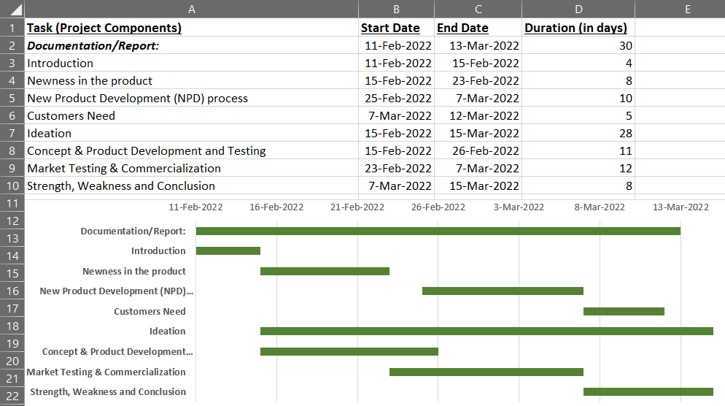

**MARKING CRITERIA & MARKS ALLOCATION**

|  |  |  |  |
| --- | --- | --- | --- |
| **No.** | **Criteria** | **Marks Allocation** | **Marks Obtained** |
| 1 | Introduction and Analysis of newness | 10 |  |
| 2 | Understanding customers’ needs, ideas generations and selections, concept development and testing, product development and testing | 40 |  |
| 3 | Market testing and commercialisation | 20 |  |
| 4 | Strengths and Weaknesses and ethical implications | 20 |  |
| 5 | Citations and Referencing According to Harvard Referencing Style | 10 |  |
|  | **Total** | **100** |  |